**UID ASSIGNMENT 3**

**S.SAILOO**

**230701277**

**CLI (Command Line Interface)**

**File Renaming via Command-Line Interface (CLI) in Python**

**Introduction This document demonstrates how to rename a file using a Python script via command-line arguments. The process is illustrated through an example, showing the execution of the script and its output.**

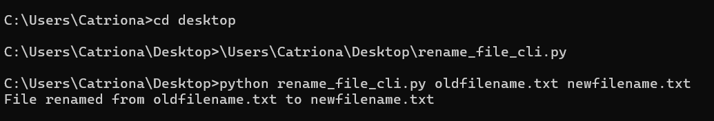

**Conclusion: The Python script successfully renames the file using the specified command-line arguments. The process is simple and efficient for handling file renaming operations in a command-line environment.**

**GUI (Graphical User Interface)**

**File Renamer GUI Documentation**

**Introduction**

**The File Renamer GUI is a simple graphical user interface (GUI) created using Tkinter that allows users to rename files easily. It provides input fields to enter the old and new filenames, and a button to perform the renaming operation. Users receive feedback through message boxes.**

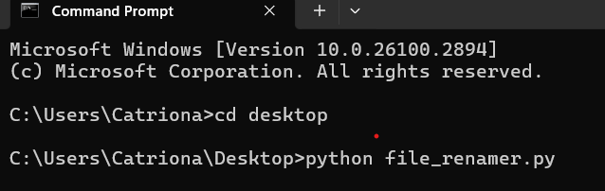 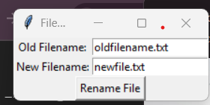

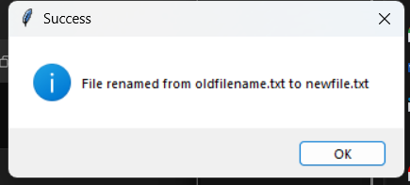

**VUI (Voice User Interface)**

**For the VUI, we can use the SpeechRecognition library to listen for voice commands. The user will say something like, "Rename oldfilename.txt to newfilename.txt."**

